Solution to every third end-of-chapter problem
Basics of Engineering Economy, 2nd edition
Leland Blank and Anthony Tarquin

Chapter 13

After-Tax Economic Analysis

13.1 (a) From Table 13.1, marginal tax rate = 39%

(b) Taxes = 0.15(50,000) + 0.25(75,000 – 50,000) + 0.34(100,000 - 75,000) +
0.39(250,000 – 100,000)
= $80,750

(c) Average tax rate = (80,750/250,000)(100%) = 32.3%

13.4 TI = 450,000 – 230,000 – 48,000 = $172,000

Approximate taxes = 172,000(0.38) = $65,360

13.7 (a) TI = 320,000 – 149,000 – 95,000 = $76,000

(b) Use Table 13-1
Taxes = 13,750 + 0.34(76,000-75,000) = $14,090

(c) T_{e} = 10.5 + (1 – 0.105)(18.5) = 27.06%
Tax estimate = 76,000(0.2706) = $20,566
Percent of GI = 20,566/320,000 × 100% = 6.43%

13.10 Before-tax ROR: 0 = -500,000 + 230,000(P/A,i*,5) + 100,000(P/F,i*,5)
i* = 38.48% (spreadsheet)

After-tax ROR = 38.48(1 – 0.35) = 25.01%

13.13 Missing values are shown in bold red in the table

CFBT₂ = 950 – 150 = $800

D₂ = 0.4445(1900) = $845

D₄ = 0.0741(1900) = $141

TI₃ = 600 – 200 – 281 = $119

Taxes₂ = -45(0.35) = $-16

CFAT₃ = 400 – 42 = $358

Year | GI | E | P and S | CFBT | D | TI | Taxes | CFAT
0 |  |  | $-1900 | $-1900 |  |  |  | $-1900
1 | $800 | $-100 | 0 | 700 | $633 | $ 67 | $23 | 677
2 | 950 | -150 | 0 | 800 | 845 | -45 | -16 | 816
3 | 600 | -200 | 0 | 400 | 281 | 119 | 42 | 358
4 | 300 | -250 | 700 | 750 | 141 | -91 | -32 | 782

13.16 GI can be determined from the data provided.

CFBT = CFAT + taxes
GI – E = CFAT + (GI – E – D)(T_{e})

Solve for GI to obtain a general relation for each year t.

GI_{t} = [CFAT + E_{t}(1- T_{e}) – D_{t}T_{e}]/ (1- T_{e})

where CFAT = $2.5 million
T_{e} = 8% + (1-0.08)(20%) = 26.4% (0.264)
1- T_{e} = 73.6% (0.736)

Year 1: GI₁ = [2.5 million + 650,000(0.736) – 650,000(0.264)]/0.736
= $3,813,587

Year 2: GI₂ = [2.5 million + 900,000(0.736) – 900,000(0.264)]/0.736
= $3,973,913

Year 3: GI₃ = [2.5 million + 1,150,000(0.736) – 1,150,000(0.264)]/0.736
= $4,134,239

13.19 Total depreciation was 20% + 32% + 19.2% + 11.52% = 82.72%
BV₄ = 80,000 – 80,000(0.8272)
= $13,824 < selling price of $15,000. Depreciation recapture is present

DR = 15,000 – 13,824
= $1176

13.22 Calculate taxes = GI – E – (TI + DR)(T_{e}) for each year and add. System 2 has lower total taxes by $26,600. Spreadsheet solution follows.

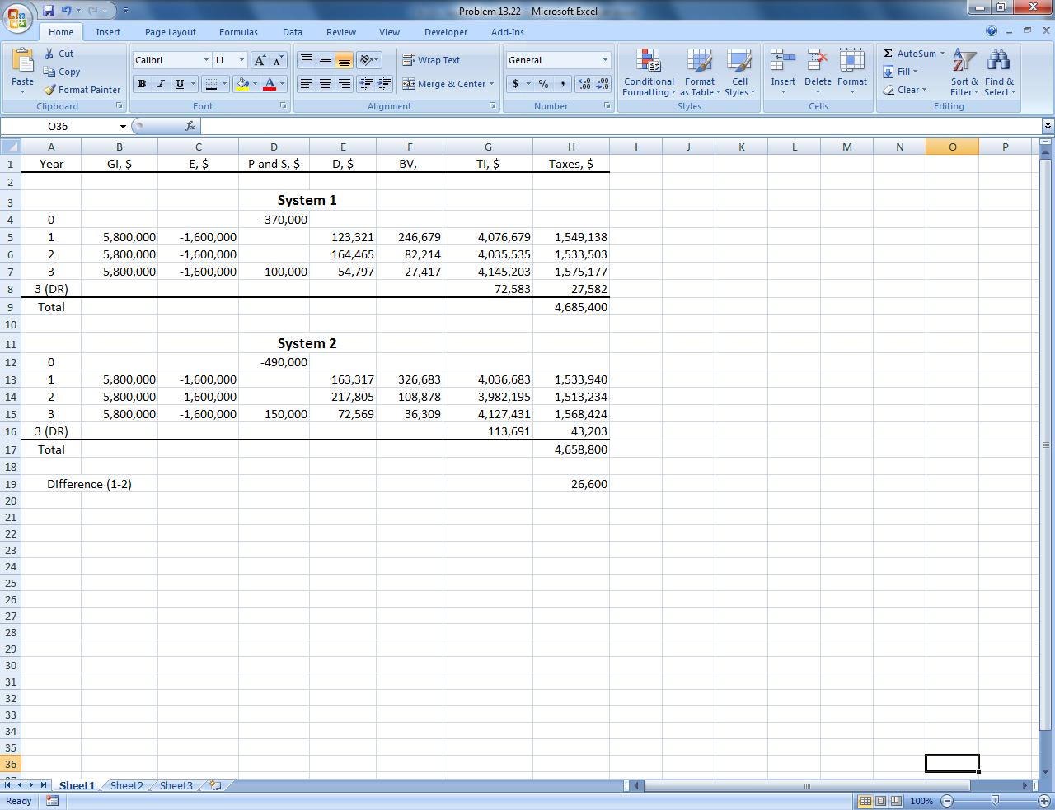

13.25 (a) MACRS depreciation

Year | P and CFBT, $ | Rate | D, $ | TI, $ | Taxes, $
0 | -200,000
1 | 75,000 | 0.2000 | 40,000 | 35,000 | 13,300
2 | 75,000 | 0.3200 | 64,000 | 11,000 | 4,180
3 | 75,000 | 0.1920 | 38,400 | 36,600 | 13,908
4 | 75,000 | 0.1152 | 23,040 | 51,960 | 19,745
5 | 75,000 | 0.1152 | 23,040 | 51,960 | 19,745
6 | 75,000 | 0.0576 | 11,520 | 63,480 | 24,122
7 | 75,000 | 0 | 0 | 75,000 | 28,500
8 | 75,000 | 0 | 0 | 75,000 | 28,500
Total |  |  |  |  | $152,000

PW_{tax} = 13,300(P/F,8%,1) + 4180(P/F,8%,2) + … + 28,500(P/F,8%,8)
= $102,119 (spreadsheet)

Straight line depreciation D = 200,000/8 = $25,000 per year

Taxes = (75,000 – 25,000)(0.38) = $19,000 per year
Total taxes = 8(19,000) = $152,000

PW_{tax} = 19,000(P/A,8%,8) = 19,000(5.7466)
= $109,185

MACRS is preferable with the lower PW_{tax} value.

(b) Total taxes are $152,000 for both methods.

13.28 (a) Defender: Capital loss = BV - Sales price = [300,000 – 2(60,000)] - 100,000
= $-80,000

Taxes = -80,000(0.35) = $-28,000

This is a tax savings for the challenger in year 0.

CFAT_{C} in year 0 = $-420,000 + 28,000 = $-392,000

CFAT_{D} in year 0 = $-100,000

(b) Defender: TI = -120,000 – 60,000 = $-180,000
Taxes = 180,000(0.35) = $-63,000
CFAT = -120,000 - (-63,000) = $-57,000

Challenger: TI = -30,000 -140,000 = $-170,000
Taxes = -170,000(0.35) = $-59,500
CFAT = -30,000 - (-59,500) = $29,500

(c) AW_{D} = -100,000(A/P,15%,3) – 57,000
= -100,000(0.43798) – 57,000
= $-100,798

AW_{C} = -392,000(A/P,15%,3) + 29,500
= -392,000(0.43798) + 29,500
= $-142,188

Keep the defender

13.31 The debt portion of $15 million represents 40% of the total.

Total amount of financing = 15,000,000/0.40 = $37,500,000

13.34 Company’s equity = 30(0.35) = $10.5 million

Return on Equity = (4/10.5)(100%) = 38.1%

13.37 (a) WACC_{A} = 0.5(9%) + 0.5(6%) = 7.5%

WACC_{B} = 0.2(9%) + 0.8(8%) = 8.2%

Plan A has a lower WACC

(b) Let x = cost of debt capital

WACC_{A} = 8.2% = 0.5(9%) + 0.5x
x = 7.4%

WACC_{B} = 8.2% = 0.2(9%) + 0.8x
x = 8.0%

Plan A cost of debt goes up from 6% to 7.4%; Plan B maintains the same cost.

13.40 (a) Determine the after-tax cost of debt capital and WACC.

After-tax cost of debt capital = 10(1-0.36) = 6.4%

After-tax WACC = 0.65(14.5%) + 0.35(6.4%) = 11.665%

Interest charged to revenue for the project:
14 million × 0.11665 = $1,633,100

(b) After-tax WACC = 0.25(14.5%) + 0.75(6.4%)
= 8.425%

Interest charged to revenue for the project:
14 million × 0.08425 = $1,179,500

As more and more of the capital is borrowed, the company risks
higher loan rates and owns less and less of itself. Debt capital (loans) will
get more expensive and harder to acquire.

13.43 Find BV_{t -1} = BV₁; solve for NOPAT; find TI from NOPAT; solve for E from TI.

BV₁ = 550,000 – 550,000(0.3333) = $366,685

EVA₂ = 28,000 = NOPAT – (0.14)(366,685)
NOPAT = $79,336

NOPAT = 79,336 = TI(1 – 0.35)
TI = $122,055

D₂ = 550,000(0.4445)
= $244,475

122,055 = GI - E - D
= 700,000 - E - 244,475
E = $333,470

13.46 T_{e} = 0.08 + (1 – 0.08)(0.34) = 39.3%

Answer is (b)

13.49 Answer is (d)

13.52 CFAT = GI – E – TI(T_{e})
26,000 = 30,000 – TI(0.40)
TI = (30,000 – 26,000)/0.40 = $10,000

Taxes = TI(T_{e}) = 10,000(0.40) = $4000

TI = GI - E – D
10,000 = 30,000 – D
D = $20,000

Answer is (d)

13.55 BV₅ = 100,000(0.0576) = $5760

DR = 22,000 – 5760 = $16,240
Tax on DR = 16,240(0.30) = $4872

Cash flow = 22,000 – 4872
= $17,128

Answer is (b)

